**D2 – Explain how the width of the data bus and address bus affect processor performance and complexity**

**Introduction**

In this report, I will be evaluating the performance of a computer system. By this, I will be recommending a system, and suggesting one and explaining the effects of it.

**Present Specification**

|  |  |
| --- | --- |
| Packard Bell Easy Note ME69BMP-28062G32nii - 10.1" - Celeron N2806 | Actual Price: £157.09 |
| [http://cdn.cnetcontent.com/92/3d/923d4f58-3df6-481d-9785-3e6672262a1a.jpg](http://cdn.cnetcontent.com/d8/6d/d86d560f-c696-47fc-8a3a-5bfeca120222.jpg) | | Specification |  | | | | --- | --- | --- | --- | | Processor |  | : | Intel Celeron N2806 | | RAM |  | : | 2GB | | Hard drive |  | : | 320 GB | | Screen |  | : | 10.1” | | Operating System |  | : | Windows 8.1 | | Platform Technology |  | : | Laptop | | CPU Speed |  | : | 2 GHz | | Cache |  | : | 1 MB | |
|

This is the present specification that I will be using for it. As you can see, the RAM is 2GB. The 2GB RAM allows you to multitask on any program and save many documents. The more RAM you have, the faster it can be used. The operating system is Windows 8.1, and it will allow the user to use more features than Windows 7.

The benefits of using a laptop is that it is portable for users. Anyone can to complete their work anywhere. Even if they are on the way to University and an assignment is due in the morning, they can take their laptop with him/her and complete it on the train/travel/use at university as well. Some of the issues of using the laptop is the internet connectivity. Because this platform is portable, you will need internet connectivity wherever you go. The internet requires Wi-Fi and that is private, which requires a password. He will need a wireless router that connects to the internet wirelessly.

**Data Bus**

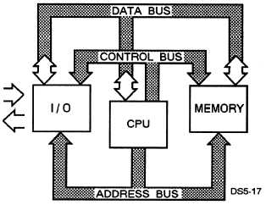Data bus is designed to control the data. They are wires that make up these buses and these wires are the width of the bus. Data bus consists of 32 wires and these wires can be connected with two or more components within the computer. These wires are used to send information between the two. In this case, this bus will send data. Referring to the image below, data bus can send information between each of the components. For example, Input/output can transfer data between the two with memory using data bus. If I were to send data to another computer, within this system, data bus can send it from I/O to memory.

**Address Bus**

Address bus is similar to ‘data’ bus, but does the total opposite. This bus delivers the destination that the user requires. This means, if I were to send an email to my teacher, it would travel from I/O to its destination. This has 32 wires, same as data bus. The picture above shows how the address bus works. It gets the picture, email or whatever it needs to send to another person and it locates it by the IP address and sends it. It is simple the way it works.

**Direct Memory Access (DMA)**

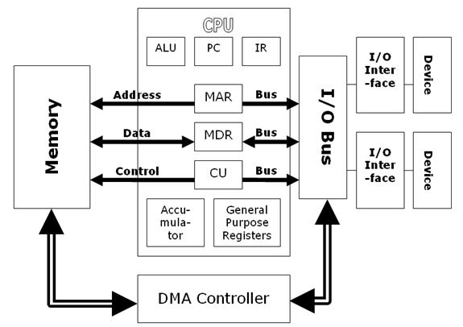DMA is a feature that allows the user to gain access to the main memory, and by being independently, the CPU cannot do it all itself. DMA allows the user to interpret, and send any attached device from the peripheral (output) to the memory on the computer’s motherboard. These files can be large, and using DMA, it is beneficial in this sense. As you can see on the picture (left), it shows how the DMA communicates. It communicates with the I/O bus. Each of the I/O bus is connected with a device. This enables communication between the two.

**How it affects the performance?**

This affects the performance by slowing it down if too many commands have been sent to the processor. For example, if you were to have at around 6-7 applications on, the computer would crash because they are too many things going on. Also, this depends on the RAM as well. If the RAM is increased, the flow of the whole performance would be better. The DMA is important too. If any user was to send a large file to another user, the DMA would control it and do it. However, it depends on the speed of the computer. It can affect it by the transfer being complete in seconds or longer. Referring to the image, we always want the performance to increase each time we use the computer.



For the buses, the performance is effected by the bandwidth of the computer. If the bandwidth is not in range, the performance of the computer will be effected a lot.

**Suggested Specification**

|  |  |
| --- | --- |
| HP ENVY 17-j053ea 17” Laptop - Silver | Actual Price: £899.99 |
| <http://brain.pan.e-merchant.com/3/8/21492783/l_21492783.jpg> | | Specification |  | | | | --- | --- | --- | --- | | Processor |  | : | Intel® Core TM i7 | | RAM |  | : | 12GB | | Hard drive |  | : | 1 TB | | Screen |  | : | 17” | | Operating System |  | : | Windows 8.1 | | Platform Technology |  | : | Laptop | | CPU Speed |  | : | 2.4GHz | | Cache |  | : | 6 MB | |
|

This is the suggested specification that you could use. In this table above, it demonstrates the key aspects of what the laptop includes. I recommend this laptop, as it is portable easy and key to use because it could last more than 4 years. The laptop is powered by the 2nd generation Intel Core i7 that makes light work of everyday tasks such as typing up documents. The Core i7 is Intel's current most powerful processor; most have clock speeds or GHz. The advantages using Intel Core i7 is:

* **Integrate four Cores (latest Core i7 processor incorporate 6 cores)**
* **Speed ranges from 2.66GHz to 3.33GHz**
* **Front Side Bus Speed include 2GHz, 4.8GHz or 6.4GHz**
* **Support DDR3 main memory**
* **1MB L2 and 8MB L3 cache**
* **Enhanced Intel SpeedStep Technology**
* **Virtualization Technology**
* **Streaming SIMD Instructions (MMX)**
* **Over clocking capability**

The 12GB RAM allows you to multitask on any program and save many documents. Windows 8.1 introduces new applications; start screens, which makes this laptop more natural. Comparing it with the present specification, the RAM is 2GB and it only limits what you can do. In terms of cost, just the laptop, I think it is worth the money because putting all the key features of the laptop together, makes it worthwhile. The company is HP as I think it lasts long and it should be in the top 10 of the top brands. The benefits of using a laptop is that it is portable for users. Anyone can to complete their work anywhere. Even if they are on the way to University and an assignment is due in the morning, they can take their laptop with him/her and complete it on the train/travel/use at university as well. Some of the issues of using the laptop is the internet connectivity. Because this platform is portable, you will need internet connectivity wherever you go. The internet requires Wi-Fi and that is private, which requires a password. He will need a wireless router that connects to the internet wirelessly.

Therefore, you would need internet at your house and to use the internet. As this is a laptop, I think that getting insurance for this laptop is necessary. It includes a 5-year deal with a payment of £300 for the full 5 years. The insurance includes if any damages to the laptop, PC World would fix the problem.

**Used in 32 bit and 64 bit processors**

They are both different as both are used differently for different processors. 32 bit is used for both processors, Intel and AMD. This was used very early on once the computers were released. So, 32 bit was used for Windows 95, 98 and XP. 64 bit is used for the latest operating system, which are Windows 7, 8 and Vista. The difference for the two is the memory The RAM for it is different, and 64 bit can be used over 4GB whereas 32 bit cannot be used over 4GB. 32 bit and 64 bit are used in three precision that is used in the languages. The three precision is the following:

* Single precision – This is used in the C language family. The binary format is used in the 32 bit.
* Double precision - This is used in the same as single precision, but it is doubled. Therefore, it uses 64 bit in the binary format.
* Double extended – This is extended from the double. Therefore, the binary format would be used more than 64 format.

All of these above are used in either one of the two processors. These two pictures show how they are both represented in 32 bit and 64 bit.

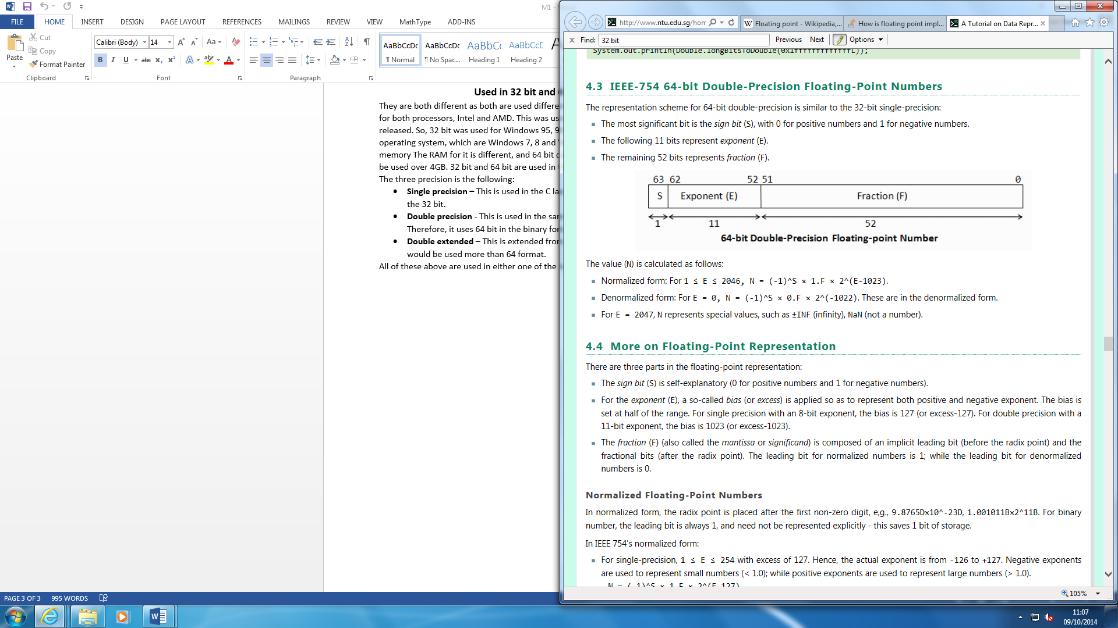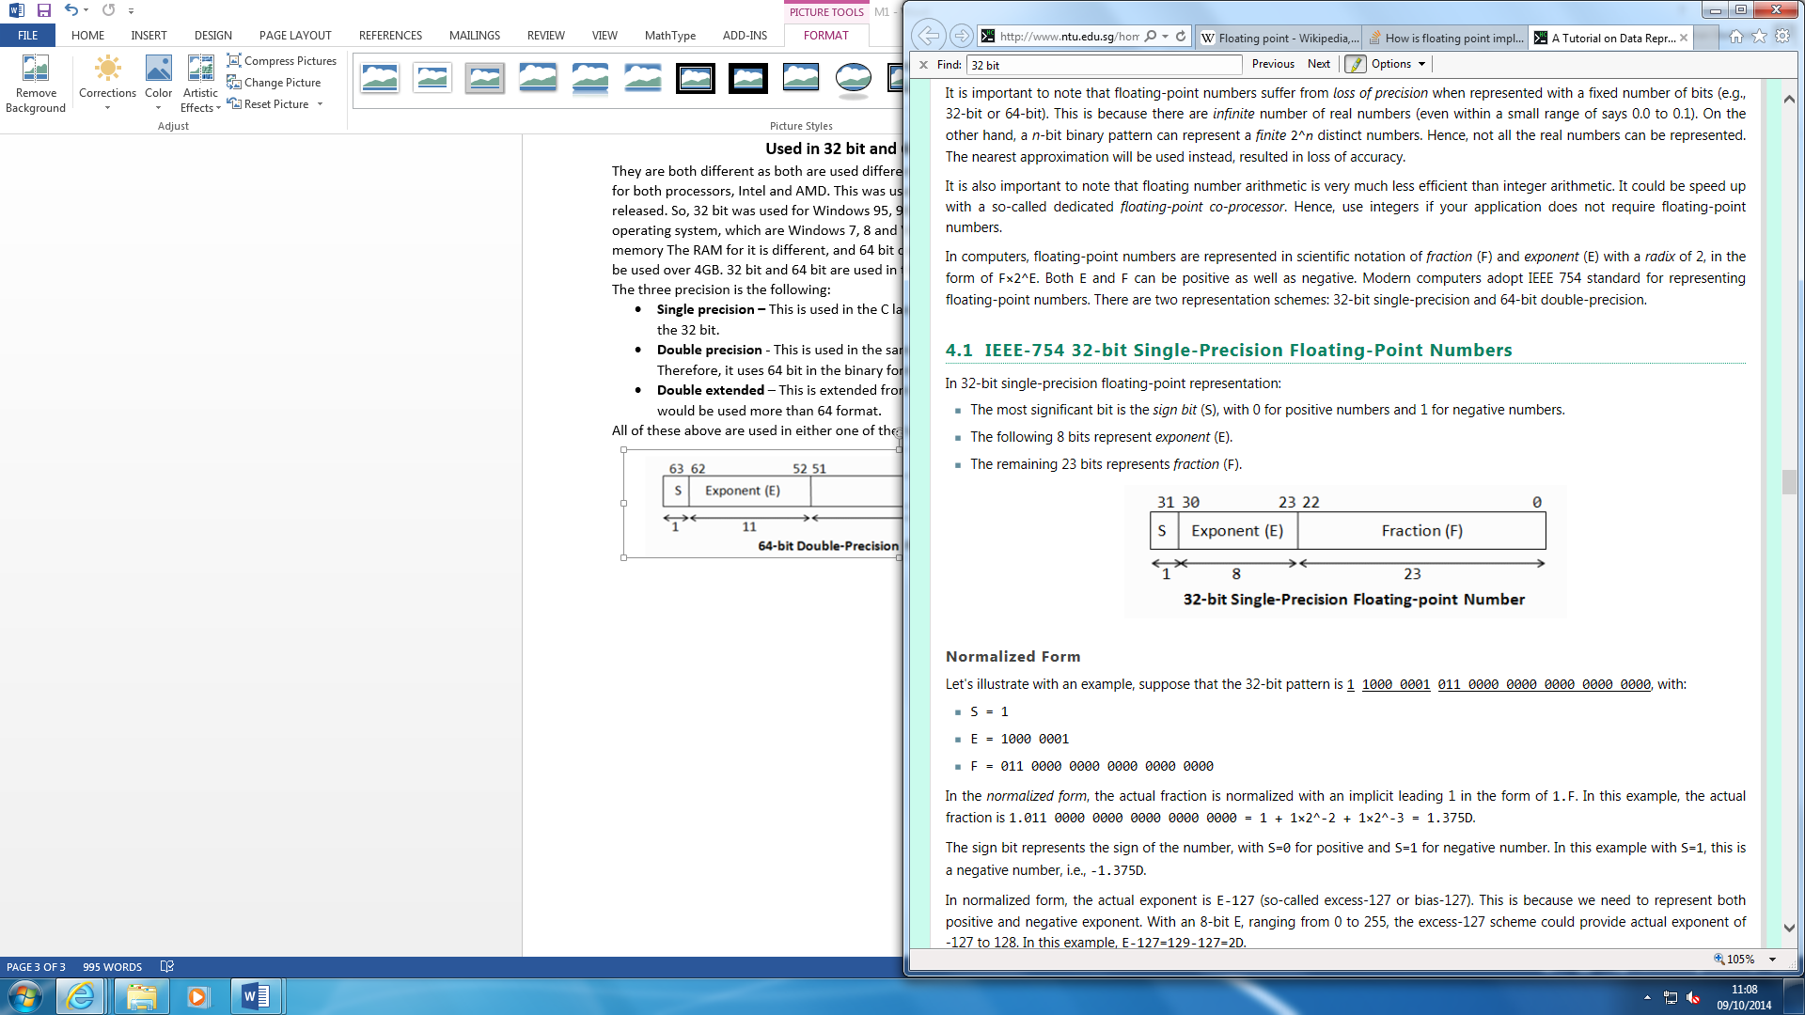

**Reference**

<http://www.pcworldbusiness.co.uk/buy-rent/P201841P?cidp=Froogle&gclid=CO27pdOPhMMCFaXnwgod8wIA1A>